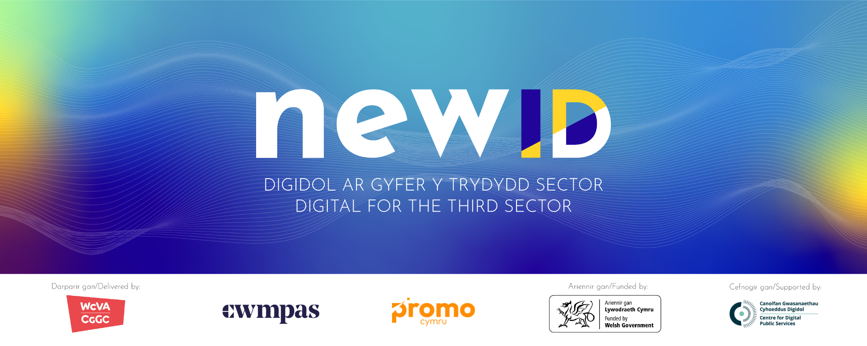

**Newid Discovery Report with County Voluntary Councils**

**March 2025**

Research carried out by ProMo Cymru

**Introduction**

Newid promotes good digital practice across the Third Sector in Wales. We do this by providing training, support and information. It is a partnership between WCVA, ProMo Cymru and Cwmpas, supported by The Centre for Digital Public Services, and funded by the Welsh Government. What Newid delivers is based on the needs of the Welsh Third Sector and the communities it serves.

As part of [previous research](https://www.newid.cymru/digital-needs-of-the-welsh-third-sector-newids-2024-discovery-report/) conducted with third sector organisations in Wales, we learnt that:

* Organisations are seeing an increase in demand for their services, made worse by the cost-of-living crisis and the growing needs of their service users.
* There’s a need for organisations to boost their digital skills and ways of working to stay sustainable and thrive.

We know that County Voluntary Councils (CVCs) play a crucial role in supporting these organisations, acting as a bridge between third sector organisations and the resources they need.

The aims of this Discovery Report are:

* To gain insights into the types of digital requests CVCs receive and the support they offer to their member organisations.
* Understand their strategy for the future, particularly around digital transformation.
* Explore opportunities for collaboration between CVCs and Newid to support the sector going forward.

We conducted 4 semi-structured interviews with CVCs as well as an ideation workshop with 6 participants and Newid staff. Below are the insights we gathered from those discussions.

**Current understanding of digital**

When we asked CVCs staff what comes to mind when they think about digital in an organisational setting, the responses were varied, highlighting just how broad and complex the term can be. Some associated the term with “chaos”, digital inclusion, cyber security or technical aspects like hardware and networks, while others viewed it as the way organisations can engage with their audiences and users.

This definition resonated with some “*Applying the culture and technologies of the Internet-era to make our organisations more resilient and responsive to the changing expectations, needs, and behaviours of the people we support.*” (Tom Loosemore, adapted by CAST). One person commented “This is clear. Talking about culture and behaviour is not something we usually talk about when we talk about digital.”

However, concerns were raised about its inclusivity, noting the language is not that accessible - “it’s full of jargon” - and not everyone has the skills or wants to use digital systems.

Everyone we spoke to mentioned tackling digital exclusion as a priority. It’s important to note that Digital Communities Wales (DCW)’s remit is to help people get online whereas Newid is focused on supporting Third sector organisations to maximise their impact through the safe and effective application of digital technology.

**The role of digital in the third sector in Wales**

Digital was seen as a priority development area. CVC staff have noticed a shift in organisations recognising they need to be more digitally savvy to be sustainable.

Digital tools were seen as essential for the future of the sector, offering ways to streamline processes, save time, and reach wider audiences. However, CVCs pointed out that while digital plays an important role, with so much happening online, it can be overwhelming and hard for organisations to actually find the information, training or opportunities they may need. With such limited resources, how do we help people know what’s right for them? For example one CVC asked, “how do organisations know if they need Cyber essentials? It’s a big investment, very technical to go through and has an annual fee attached. Is it an essential requirement?”

They also noted that digital can be useful in terms of making services more accessible, however there is a danger of excluding people who lack the skills to use those digital services. There is also a view that organisations are better at face to face delivery as “we’re not super clear on what is good quality when we talk about digital services.”

Taking meetings and training online has been transformational for our sector, however making an online session engaging requires different skills.

**The role of CVCs in supporting the sector with digital**

When asked in what ways they currently help their member organisations with digital, CVCs said they support organisations with funding and tenders applications, and share information about training opportunities as well as delivering training themselves (for instance around Canva, Zoom, social media, etc.). They also talked about work they’ve done in supporting the community to be digitally included.

CVCs shared that effective digital support is tailored, practical, and focused on meeting specific needs. Quick, practical solutions were particularly appreciated for tackling immediate challenges. On the other hand, support that felt too generic, overwhelming, or sharing costly digital tools or platforms was seen as a barrier, highlighting the importance of a more personalised approach.

CVCs also identified key areas where support is most needed such as working in the cloud (how best to use Office 365 and Google), admin software and data management, tools for reporting, making online sessions more engaging, cybersecurity and risk management, any new developments (for instance AI), marketing (including social media and websites) and how to use and where to find free or low cost platforms. It was also mentioned that people need help with what hardware to buy, for example what’s the best video conferencing setup? What kit is needed to run a hybrid meeting?

For CVCs to be able to support the sector with digital, there is a need for CVCs to upskill “We need to get confident ourselves before we can talk to people about it.” There was a willingness to develop and learn, but it’s not always easy to know what you need to upskill in, one person said “you don’t know, what you don’t know”. On top of this, participants pointed out that CVCs must be equipped to effectively signpost their members. This raises important questions: Where should signposting responsibilities begin, and where should CVCs' direct involvement end? Additionally, how much upskilling is required for CVCs, and what tasks should be left to external resources?

From the conversations, it was clear that CVCs are doing important work supporting people with basic digital literacy, such as signing up to funding portals and listing volunteering opportunities. They stressed that often when it comes to an introductory level of how to login and use a tool, people need this support face to face and “for those who have a bit more confidence about the basics, they don’t mind going online.”

**Sharing opportunities**

Trust is key when it comes to sharing opportunities like training and resources. CVCs emphasised the need for organisations to be able to recognise the provider as a trusted source of information. Regarding sharing opportunities for CVCs to pass on to their networks, they say email is preferred, with opportunities then shared through CVC newsletters, social media, websites, and forums. To make this easier, Newid can provide ready-made bilingual, shareable materials, like posters or pre-written content, so the information is simple to pass on.

Because of the overwhelming flow of information online, physical materials, such as flyers and posters, are still essential for reaching certain audiences. Any content shared needs to be specific, relevant, and tailored to the sector’s current needs, with a focus on clear, accessible, and localised language. CVCs also stressed the importance of sharing information that is both relevant and timely. Before passing on opportunities, they ensure these align with the needs of the sector and bring clear benefits to their members.

**Collaboration between CVCs and Newid**

The third sector in Wales continues to face significant barriers to digital adoption, including limited time, funding, and skills. Despite these hurdles, there’s a clear recognition that digital tools can streamline processes, improve efficiency, and ultimately free up time to deliver core work.

Looking ahead, collaboration will play an important role. CVCs suggested creating and sharing bespoke training and information, building informal peer support networks, and developing a central hub for digital resources. Longer-term goals included upskilling teams, improving internal systems, and embedding digital practices across organisation's strategies.

CVCs play a crucial role in ascertaining need, they are often the first point of support for third sector groups within their communities. How can we work together to better understand the needs and respond collaboratively?

**Ideation**

We held an ideas generation workshop with 6 CVCs and Newid staff in December 2024 and several actionable ideas emerged to support digital development, some of which are already covered by Newid or elsewhere in the ecosystem - for instance, [Digi Cymru](https://promo.cymru/project/digicymru/) (a service offering free 1-1 digital support), content available on the [Newid website](https://www.newid.cymru/), and free training opportunities. However, a significant challenge is that people aren’t aware this support exists. Therefore, we decided to focus our effort on taking forward ideas that focused on raising awareness and building a community.

These include delivering short, bitesize "how-to" sessions on specific topics, setting up quick communication channels like a WhatsApp group for sharing tips, identifying a named person within each CVC who is passionate about digital and willing to collaborate with Newid and scheduling quarterly meetings to discuss digital strategies.

Participants also highlighted the need for a clear, working definition of digital skill levels, such as 'poor,' 'good,' and 'excellent.' There was also a strong interest in increasing awareness and usage of Free Open Source software, such as Linux and LibreOffice. These last two points are something we are looking to address later on.

In January 2025, we held a wider CVC engagement session which was attended by over 30 members of the CVC practitioner networks, representing 18 CVCs, where we consulted the group on 4 ideas:

* a CVC Peer Network for Digital
* Quarterly digital conversations (A mixture of talks, conversations and workshops on a specific topic, chosen by the network. A space to share challenges and successes.)
* A WhatsApp community
* Identifying a named person within each CVC who is passionate about digital, who the Newid team can engage with (creating a stronger link to share opportunities, news, discuss community needs and collaborate).

We gathered feedback on the ideas, which we then shared with Chief Officers at their February huddle.

**Conclusion and next steps**

The key insight that emerged from this research is that many of the challenges we face stem from a lack of communication between Newid and the CVCs. Improving these communication channels is essential for collaboration and ensuring everyone has a space to discuss shared challenges and opportunities. This could form both the conclusion and the overarching strategy moving forward: **How do we create a space that encourages open, consistent conversations about digital support?**

Some encouraging steps are already underway. For example, after the wider CVC engagement sessions, SCVS got in touch to arrange for the Newid team to speak to the Volunteer Managers Network in Swansea about digital solutions to managing volunteer data, —an early but very positive outcome. Additionally, four CVC staff instantly signed up for the Newid newsletter directly after the session showing an interest in staying connected and informed.

Following the consultation, the ideas of setting up a WhatsApp group chat or designating a digital lead within each CVC were poorly received by some CVC staff. However, the quarterly meetings and sessions on specific topics were very well welcomed. Our next challenge is to build on this momentum by taking those two ideas forward.